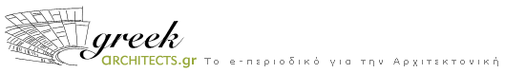

Assignment of article’s publication

DATE: ….. / ….. / 2008

With the present document I declare that I concede to the e-magazine Greek Architects (www.greekarchitects.gr) the authority to publish my articles (text and pictures) titled:

1) …………………………………………………….

This concession aims the moral and legal consolidation of Greek Architects (www.greekarchitects.gr ), in admission that it doesn’t publish illegal and irresponsibly researches and articles without the permission of their author.

Personal author’s details:
Surname :………………...............................................................................

Name :.....................................................................................................

Status:........................................................................................................

Address:.........................Number:….. City:………… Postal Code.:........Country:……….

Phone Number:.....................................................................................................

Terms:
Greekarchitects.gr has the right to maintain this article in his pages for one (1) year. In case that author desires it’s recession after one year of its publication, he has to apply in black and white his demand at the address of our magazine:
Galli Rovertou 35 (11742) Acropolis, Greece, otherwise it will remain in our site for as long is considered necessary.

Greekarchitects.gr has the right to withdraw the article at anytime without the obligation to notify the author. The author merely has the responsibility for the content of the publication, regarding the article and the pictures.

The author is obligated to assure before the publication of his article the Copyright or the written assignment of the royalty, for the pictures that the text includes.

Signature

