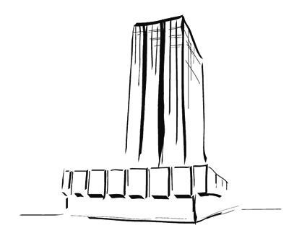
Piraeus Tower 2010 -
Changing the Face
GreekArchitects.gr and DuPont invite you to the exhibition opening and announcement of the Architectural Competition’ s results on 24th of June in Athens



Press Release
The members of the organisational and jury committee, GreekArchitects.gr and DuPont invite you to the exhibition opening of the international architectural competition “Piraeus Tower 2010 - Changing the Face” on Thursday 24th of June at 19.30 pm at the cultural centre Athinais (Kastorias 34-36, Votanikos, Athens, Tel. +30 210 3480000).
The results of the competition will be also announced and the members of the organisational and jury committee will address speeches.
The exhibition, which will continue until the 27th of June, will present the 380 proposals that 949 studiers from 44 countries have submitted.
Speakers (there might be some changes)
Anastasakis Manolis, architect, organisation Head of the competition
Citerne Anne-Line, Material engineer, DuPont representative
Dragonas Panos, architect, a. professor of Architecture University of Patras.
Kalogirou Nicos, architect, professor of Architecture University of Thessaloniki-AUTH
Kotionis Zisis, architect, professor, dean and chairman of Architecture University of Volos
Tompazis Alexandros, architect
Tripodakis Alexandros, architect, professor of Architecture University of Crete.
Thanos Stasinopoulos, architect, lecturer of Architecture University of Patras
Coordination
Vandoros Alexios, architect, chief editor & press representative of the competition
Curator
Vassilis Mistriotis, architect, GreekArchitects.gr Director

Exhibition Duration: June, 24-27
Place: cultural centre Athinais
Opening hours: 10:00 until 19:00
Supporters:
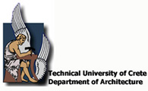   
Mega sponsor:

Gold sponsors:

Silver sponsors:
 
Sponsors:

Communication sponsors




Exhibition sponsors:

Companies willing to sponsor the competition can apply at info@greekarchitects.gr or call at +30 210 3636631
“The members of the Jury committee, GreekArchitects.gr and DuPont, wish to sincerely thank all those who participated in our competition. The number of participations exceeded every initial expectation, as 380 proposals were ultimately submitted, by 949 studiers from 44 countries. The fact that many participants actually visited the Piraeus Tower in order to gather more details and information about the building, as well as the inclusion of the competition in the academic curriculums of international technical universities, demonstrates how the Tower of Piraeus evolved from an ideas’ competition to a research and study field project”, said Vassilis Mistriotis, Director of GreekArchitects.gr and Coordinator of the Competition Steering Committee.
“Athens is the most successful example of the “Changing the Face” competition, a concept that was initiated in Rome, in 2008, and was then developed in Bucharest, Prague, Zagreb and Moscow. The number of participations, as well as the interest received for the contest in Athens is indeed impressive”, said Wlodek Sobon, DuPont Building Innovations Central Europe.
It should be underlined that the “Changing the Face” competition, which was proclaimed in January 2010 by GreekArchitects.gr and DuPont , aimed at re-designing the face of the Piraeus Tower. Yet, the real challenge was to reassess the role of the tallest building in the Piraeus Port – and second tallest in Athens – which remains one of the most widely known unfinished projects since 1974- and also to leverage the Tower’s surface for the benefit of the local community. It should be noted that the Tower of Piraeus spans across 30,000 square meters and thus, has a significant commercial value. The competition set the grounds for the beginning of a public discourse around the Tower of Peiraus, which has become known in the course of time as “the sleeping giant”.
All proposals shall be published on GreekArchitects.gr, whereas the awarded proposals and the final results of the competition, which is supported by the Department of Architecture of the Technical University of Crete, the Council on Tall Buildings and Urban Habitat, the Vakalo School of Art and Design and the Municipality of Piraeus, will announced during the ceremony and exhibition opening on the 24th of June (time 19.30) at the cultural centre Athinais, in which the members of the organizational and jury committee will broaden the dialogue that the competition has opened.

For more information on the competition, please visit:
http://www.greekarchitects.gr/competition2010/piraeus

GreekArchitects.gr , 35 Galli Rovertou st., (TK 11742) Athens- +30 2103636631 (100)

About Greek Architects:
The e-magazine Greek Architects (GRA) was created in March 2002 aiming at offering to Greek architects an objective and full information source, and with the vision of becoming a useful tool for architects’ activities. The informative approach focuses on finding and systematically reporting on issues of theory and implementation that concern modern architects, as well as reporting on news, updates, views and materials. The magazine is targeting architects and civil engineers and is updated on a daily basis with new feature pieces, presentations, articles and more on Greek and global architecture.
About DuPont:
Founded in 1802, DuPont puts science to work by creating sustainable solutions essential to a better, safer, healthier life for people everywhere. Operating in more than 70 countries, DuPont offers a wide range of innovative products and services for markets including agriculture and food; building and construction; communications; and transportation.

